

12 PHYSICS

WAVE-PARTICLE DUALITY &
QUANTUM THEORY
ELECTROMAGNETIC SPECTRUM

Any vibrating or oscillating electric charge will produce oscillating electric and magnetic fields that are at right angles to each other. It is these fields spreading at the speed of light that we call electromagnetic radiation.

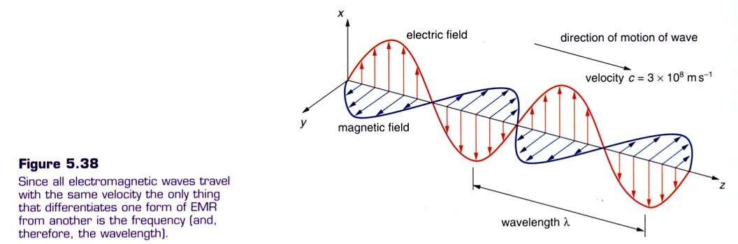

The source of the electromagnetic radiation is usually an oscillating electric charge.

(See p 215, 216 of Heinemann for more information.)

Types Of Waves

1. Power Frequencies

• Produced by alternating current (AC) generators.
• Emitted by generators and transmission lines.

2. Radio Waves

• Emitted by electrons which are forced to undergo oscillations in a wire.
• The frequency of oscillation governs the frequency of the radio waves.
• If radio waves intercept a conductor of appropriate length (1/2 of the wavelength of the
wave) they start electrons in the conductor oscillating at the same frequency. This is the
basis of an aerial or antennae.

3. Microwaves

• Generated in magnetrons and klystron tubes where electrons are made to resonate in a
small cavity.
• Used in radar, communications and microwave ovens.

4. Infra-Red

• Produced by excited outer electrons in atoms and molecules returning to their ground
state.
• Felt as heat on the skin.

5. Visible

• Produced as per infra-red.
• Allows animals to see objects.

6. Ultra-Violet

• Produced as per infra-red.
• Produces tanning/skin cancers in humans, allows plants to photosynthesise, important in
the formation of photochemical smog.

7. X-Rays

• Produced by rapidly decelerating electrons after hitting a metal target, as well as inner
electrons of atoms returning to their ground state.
• Useful for diagnosis of medical problems inside the body.

8. Gamma Rays

• Produced by the oscillation or acceleration of charges within the nuclei of atoms.
• Useful in industry to detect problems with structures involving steel and concrete.

Dual Nature Of Light

The present theory of light is a mixture of two competing theories - the electromagnetic theory (where light shows wave-like properties) and the quantum theory (where light shows particle-like properties).

Electromagnetic Theory

Light can be reflected, refracted and diffracted just like water waves, hence it was (before 1900) considered wave-like.

Quantum Theory

This explained other observed phenomena such as the photoelectric effect.

Electrons can be removed from certain metallic substances by light. To do this, the light is thought to be made up of “packets” or “quanta” of energy called photons.

Thus it appears light is made up of “particles”.

It is accepted by scientists that light behaves as waves or particles, depending on the experiment being performed.

See p 219 - 228 of Heinemann for more information.

THE STRUCTURE OF ATOMS

The Bohr Model

This model was used to improve an earlier attempt at describing an atom by Rutherford.

The Bohr model is based on the following ideas.

1. Electrons, which orbit the nucleus, can only have certain energies and move around in
“energy levels”. These levels are given numbers, the lowest level given number 1.

2. Electrons can only have the energy of the energy level that it was in.
i.e. Only particular energy levels are possible.

3. Photons of energy are emitted as an electron moves from a higher energy level to a
lower energy level.

At normal temperatures, electrons will fill the lowest energy levels possible. This is the ground state of an atom.

Bohr devised an equation that gives each of the energy levels in the hydrogen atom.

where n = the number of the energy level.

The value 13.6 eV is the ionisation energy of a hydrogen atom.

i.e. The energy required to totally remove an electron from the atom.

The energy is negative because it is necessary to add energy to the electron to free it from the atom.

A free electron from an atom is arbitrarily given an energy value of zero.

PRODUCTION OF LINE SPECTRA

If energy is absorbed by the atom (either by heating, absorption of electromagnetic radiation or bombardment by electrons), one or more electrons can be moved into a higher energy level. The atom is now called an excited atom.

The amount of energy absorbed by the electrons in the atom is equal exactly to the energy levels above ground state.

When the excited electrons move back to the lower energy levels, they give off an equivalent amount of energy as photons of electromagnetic radiation (visible light, UV radiation, IR radiation, X -rays, gamma rays).

When returning from higher energy levels, the electrons can transition back in one step or in several steps, releasing photons of differing frequencies.

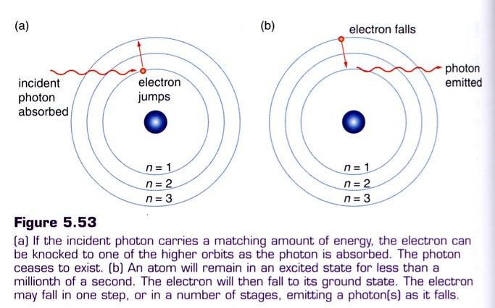

Example

Consider the energy levels of the hydrogen atom.

The particular wavelength and frequency of the radiation depends on the two particular energy levels involved.

The energy involved in the transition is given by:

where E_{photon} = the energy released by the electron as it transitions back to
its ground level (J)
E₂ = the upper energy level (J)
E₁ = the lower energy level (J)
h = Planck’s constant = 6.62 x 10⁻³⁴ Js
f = the frequency of the light emitted (Hz)
c = speed of light (ms⁻¹)
λ = wavelength of the emitted photon of light (m)

Each of the emitted frequencies of light will correspond to a particular line in the spectral lines for the atom.

Bohr’s Model can only be used to explain the spectral lines observed in the hydrogen atom.

It fails to explain the emitted spectral lines of any other gas.

Quantum mechanics, a complex mathematical model developed by scientists (de Broglie, Schrodinger, Heisenberg), accounted for the results of experimental studies. It is based on the theory that particles have some wave characteristics, just as waves exhibit certain particle characteristics.
Example 1

An electron in an excited hydrogen atom drops from the third energy level (- 1.51 eV) to the second energy level (- 3.40 eV). Calculate the wavelength of the emitted photon.

Note 1.00 eV = 1.60 x 10-19 J

Example 2

Five series of line spectra have been identified in the spectrum from an excited hydrogen atom. Three of these are the Lyman, Balmer and Paschen series.

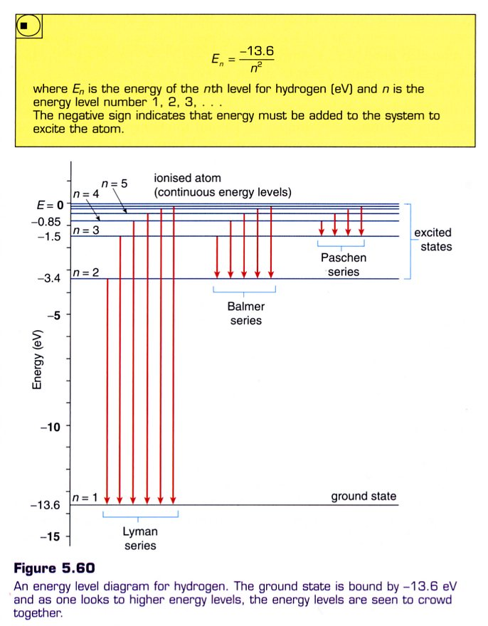

From E = hf, the larger the energy transition, the larger the frequency of the emitted light. This corresponds to the UV end of the spectrum.

∴ Lyman series is in the UV range,
Balmer series is in the visible range
and the Paschen series is in the IR
range.

Example 3

A gas atom has the following energy levels - E₁ = -3.10 x 10⁻¹⁸ J, E₂ = -1.79 x 10⁻¹⁸ J,
E₃ = -1.16 x 10⁻¹⁸ J, E₄ = -0.99 x 10⁻¹⁸ J. A sample of the gas is bombarded by a stream of electrons with energies of 2.25 x 10⁻¹⁸ J.

(a) Will the bombarding electrons be able to ionise the gas atoms? Explain.
(b) What will be the energy of the emitted photons?
(c) What will be the energy of the scattered electrons?

(a) The bombarding electrons have enough energy to reach the fourth energy level but not
enough to reach the ionisation level.

(b) Having reached the fourth energy level, there are six possible energy transitions.

E₄ - E₁ = 2.11 X 10⁻¹⁸ J E₃ - E₁ = 1.94 x 10⁻¹⁸ J

E₂ - E₁ = 1.31 x 10⁻¹⁸ J E₄ - E₂ = (2.11 - 1.31) x 10⁻¹⁸
= 0.80 x 10⁻¹⁸ J

E₃ - E₂ = (1.94 - 1.31) x 10⁻¹⁸ E₄ - E₃ = (2.11 - 1.94) x 10⁻¹⁸
= 0.63 x 10⁻¹⁸ J = 0.17 x 10⁻¹⁸ J

(c) The bombarding electrons will only lose an amount of energy equal to one of the energy
levels of the gas atom, not an amount equal to the difference between energy levels.

i.e. The absorbed energies will be 1.31 x 10⁻¹⁸ J, 1.94 x 10⁻¹⁸ J, 2.11 x 10⁻¹⁸ J.

∴ Scattered energies will be as follows.

2.25 x 10⁻¹⁸ J (electrons go through the gas without hitting an atom)

(2.25 - 1.31) x 10⁻¹⁸ = 0.94 x 10⁻¹⁸ J

(2.25 - 1.94) x 10⁻¹⁸ = 0.31 x 10⁻¹⁸ J

(2.25 - 2.11) x 10⁻¹⁸ = 0.14 x 10⁻¹⁸ J

Example 4
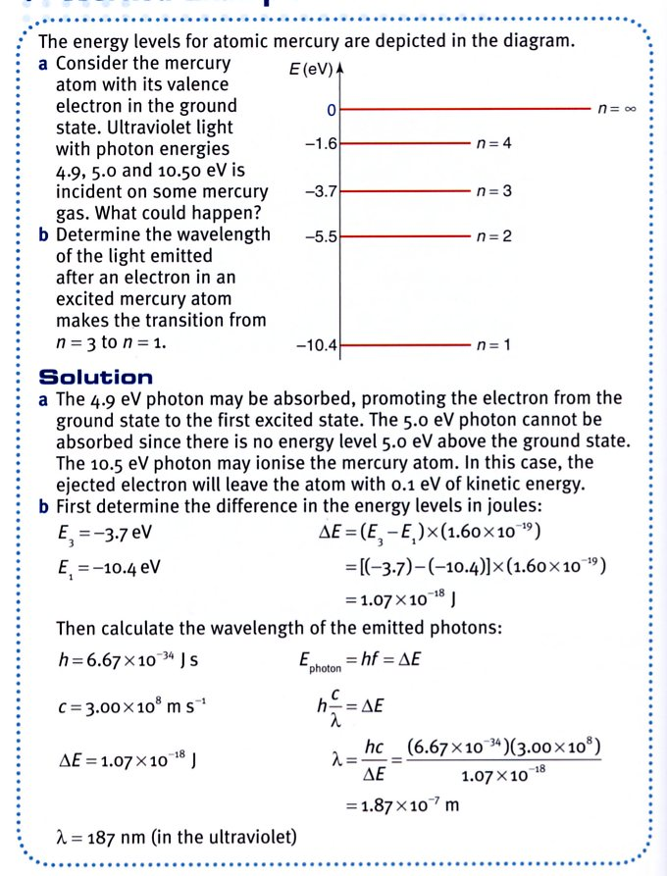
Example 5

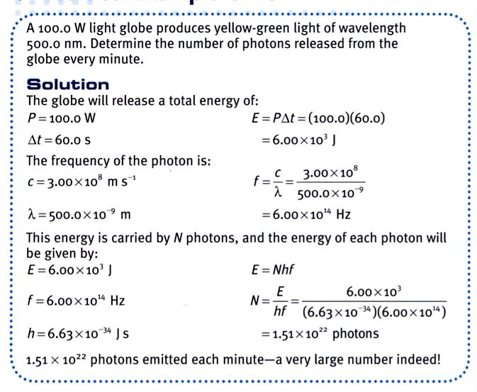
CLASSIFICATION OF SPECTRA

There are two classes of spectra - emission and absorption spectra.

Emission spectra are obtained by the dispersion of light coming directly from a source due to its bombardment by electrons or by heating.

Absorption spectra occur when light is passed through an absorbing material.

Emission Spectra

1. Line Emission Spectra

These are produced by emissions from gases under low or normal pressures.

The spectrum is a number of single, sharply-defined lines on a dark background.

Each element has its own characteristic line spectrum. It is due to this that line emission
spectra can be used to identify the constituents of unknown substances.

2. Band Emission

These are produced by excited molecules in the gaseous state. Molecules have many more
energy levels than atoms and the energy levels are in close groups.

The spectrum is made up of bands with a sharp edge and a diffuse edge on a dark background.

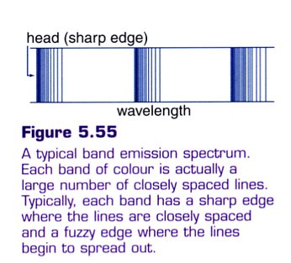
It is actually made up of a group of lines that come closer
together as they approach the sharp edge of the band.

Bands are present in the emission spectra produced from
flames.

Around the flame is a thin layer of gas (called a mantle)
which contains combustion products such as CO and
H₂O.

It is these molecules, excited by the heat of the
flame, that account for bands in the emission spectra.

3. Continuous Emission Spectra

These spectra consist of all colours from red at one end to violet at the other, as all
wavelengths of light are present.

This spectrum is produced by incandescent solids such as the tungsten filament in a light
globe, or hot liquids such as molten iron in a smelter.

This type of radiation is called black-body radiation and the specific characteristics of the
continuous spectrum depends on the temperature of the emitting solid or liquid.

At a temperature of around 1000 °K, a solid will glow ‘red hot’. The filaments of light globes
operate at around 3000 °K and glow ‘white hot’. The light from incandescent light globes is
rich in orange, red and infrared.

At around 6000 °K a black body emits a spectrum very much like the spectrum of the Sun.
Sunlight is mainly red, orange and yellow.

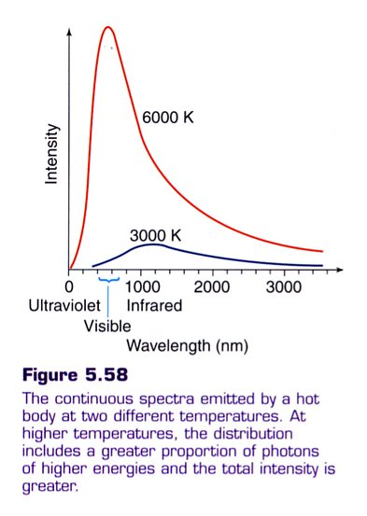

Absorption Spectra

1. Band Absorption

These are produced when white light passes through a solid such as coloured glass, or liquid
such as chlorophyll or potassium permanganate.

Dark bands on a background of a continuous spectrum are seen.

2. Line Absorption

These are produced when white light passes through a vapour or gas, producing dark lines on
a continuous spectrum.

The lines are dark and not black because the light is absorbed and then re-emitted in all
directions, so that only a small percentage is transmitted forwards to the observer or detector.

Remember that only certain frequencies of light are absorbed by the gas and the energy of
these frequencies is exactly equal to the energy levels in the atoms in the gas above the
ground state.

3. Solar Spectrum

The solar spectrum consists of a continuous emission spectrum crossed by many absorption
lines.

These lines are called Fraunhofer Lines.

They are due to selective absorption of certain frequencies of light as white light from the
interior of the Sun pass through the relatively cool vapours surrounding the Sun and the
Earth’s atmosphere.

Comparing the absorption spectrum with known emission spectra of elements has revealed
that elements such as hydrogen, helium, sodium, iron and calcium are present in the Sun.

FLUORESCENCE AND PHOSPHORESCENCE

Fluorescence

A substance that is fluorescent appears to emit its own light but is not hot.

The ability of an atom to fluoresce depends on the energy levels in the atom.

When the atom is excited from one energy state to a higher one by the absorption of a photon or by collision with an electron, it may return to its original state (ground state) by a series of two or more jumps (provided there is at least one energy level in between).

Generally fluorescence occurs by the absorption of ultraviolet (UV) light.

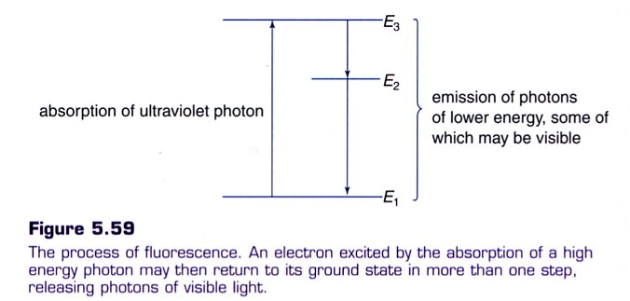

The energy of the UV photon absorbed must be exactly equal to the difference between the ground state energy and the higher energy level.

By “falling back” in two or more jumps, the energy emitted is in smaller quantities and these correspond to frequencies in the visible region.

Examples

1. Fluorescent Tube

A stream of electrons moves through a mercury vapour in the tube.

99% of the emitted energy from the Hg atoms is UV light, the rest is visible light.

This is absorbed by the white powder on the inside of the tube. It fluoresces and re-emits the
energy as visible light.

Since glass will not transmit UV radiation, the glass bulb or envelope of a fluorescent tube
will absorb the UV radiation that the fluorescent coating does not convert to visible light.
The absorbed energy will appear as heat.
2. Optical Brighteners

A practical use of this phenomenon is the addition of fluorescent "whiteners" to laundry
detergent.

These chemicals absorb ultraviolet light and re-emit the energy as blue light. Sunlight is
mainly red, orange and yellow light, giving a "yellowish" light. White colours look
"yellowish" as well as they reflect these colours.

By adding the blue light from the whiteners, the whites reflect all colours and look white.
This has the visual effect of brightening the fabric.

3. Highlighters

The substance in these pens fluoresces and gives off a characteristic colour such as green,
blue, orange, etc.

Phosphorescence

Some substances, when excited by photon absorption, form metastable states and don’t
re-emit the energy for some time. The electrons can take seconds or even hours to drop back
to their ground state so light is emitted for some time.

The process is identical to fluorescence but s called phosphorescence when there is a
significant time delay involved.

Phosphorescent substances are said to be luminous and are used in applications such as the
paint for watch dials and the coatings on television screens.

X - RAYS

An X-ray tube consists of a few basic components.

1. A heater produces electrons from the filament (called thermionic emission).

2. An electric field (produced by high voltages of about 50.0 kV or more)
accelerates electrons to very high velocities from the filament to the target.

3. Electrons decelerate rapids on hitting the target, giving some of their energy up as X-ray
(~ 5% max) and the rest as heat.

At impact, the electrons have about 5.00 x 10⁴ eV of E_{k} (calculated using W = Vq = 1/2 mv²).

The metal atoms rapidly decelerate the electrons and they lose their energy as X-ray photons and heat.

Example

Calculate the maximum frequency of an X-ray produced when an electron of 50.0 keV collides with a tungsten target and loses all of its energy as an X-ray.

When the electrons strike the target they can lose their energy in a number of ways.

• If an electron collides with the target and stops suddenly, it loses all of its kinetic energy at
once and emits a single photon equal to the kinetic energy of the electron.

Hence, the most energetic photon that can be obtained from an X-ray tube has a kinetic
energy equal to the most energetic electrons accelerated by the accelerating voltage.

(See the above example.)

• When electrons strike the target they will typically slow down in a number of collisions with
individual atoms and lose their energy in more than one step.

Consequently they will create a number of photons each with less energy than the maximum
possible photon energy.

This explains why X-ray spectra are continuous and have a wide range of photon energies up
to a maximum value.

Thus a stream of electrons, all with the same energy, will produce a spectrum of X-ray photons with many different frequencies.

This spectrum is called Bremsstrahlung radiation.

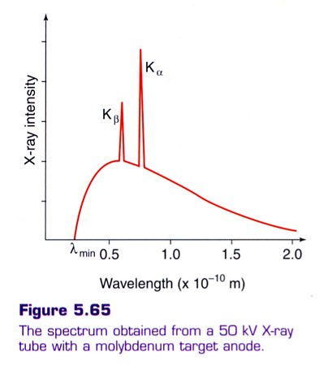

The metal target atoms will also emit a few specific X-rays due to the incoming electrons knocking inner electrons out of the atoms.

An upper energy level electron drops down to take the place of the inner electron and consequently emits a high energy X-ray photon (due to the large energy transition).

Thus a few peaks are added to the X-ray spectrum and are characteristic for that particular metal in the target.
The presence of these peaks can be used to identify metal samples as each metal produces a characteristic “finger print” with peaks corresponding to certain wavelengths.

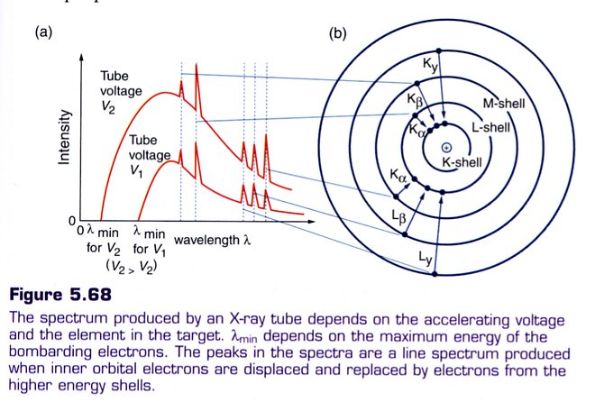

Example

